Lab Practical Prep Work and Study Guide
Name:

Part I: Identifying Properties and Textures of Rocks and Minerals

Minerals: You must be able to correctly identify physical properties of a mineral. These include luster (metallic or non metallic), Breakage (Cleavage vs. Fracture), Streak Color, and Hardness.
PHYSICAL PROPERTIES:
Metallic- Means it literally looks like a metal (IT DOES NOT MEAN SHINY!) Non-Metallic= it looks glassy, waxy, pearly, earthy/dull etc. (*Biotite and Muscovite Mica are NOT metallic because when you break them off in thin sheets they are transparent!)
Cleavage: When you can identify clean breaks in the mineral (called planes)TIP: Always look along the edges of the mineral for this
Fracture: the mineral appears to have jagged/bumpy edges or no clean cut flat surfaces when broken
Streak: Using a porcelain plate, when you scratch the mineral it will leave behind a colorless or colored powder. A porcelain plate has a hardness of ~7 so minerals like quartz will not leave a streak, but rather scratch the plate instead.
Hardness: If the mineral scratches glass (hardness= 5.5), it is considered HARD, if it doesn’t, it is considered SOFT. *Trick: Wipe the glass after you scratch it to make sure it was a scratch and not just powder from the mineral sample!

ROCKS: You will be expected to classify rocks based upon the kind of rock. This means if it is Metamorphic, Sedimentary, or Igneous. You need to be able to identify distinguishing characteristics of that specific rock group to justify your classification.

Sedimentary Features:
- Clastic or Fragmental Texture: means the rock is composed of cemented pieces
- Bioclastic Texture: Means the rock has visible shells (LIMESTONE (the coquina kind) OR that it is made from compacted plant remains (COAL)
- Crystalline Texture: it’s made from a chemical precipitate/evaporate such as rock salt, gypsum, dolomite or calcite
- The rock has fossils: The only rocks that typically contain fossils are sedimentary, so this is a dead giveaway
- Layering: Sedimentary rocks are made from sediments that accumulate in layers under watery environments and then are compacted and cemented. Layering of sediments indicates it is sedimentary.

Igneous Rocks- The main thing to know about igneous rocks is whether they are coarse grained, Intrusive (formed inside earth) or fine grained, Extrusive (formed shallow or on surface from solidifying lava). For identifying Igneous rocks vs. other rock types, here are a few distinguishing characteristics to look for.

Igneous Features:
Vesicular: extrusive volcanic rocks can have gas pockets from where volatile gases escaped when they were cooling. This is a dead give away and is not found in other types of rocks (scoria and pumice)
Glassy: typical for extremely fine grained, non crystalline rocks such as obsidian.
Random, Interlocking Crystals: When crystals appear to have no order but look like they all grew at the same time, this is random and interlocking. Granite, gabbro, diorite, have all good examples of this.
Conchoidal Fracture: Typical of obsidian, looks like a circular break mark in the rock

Metamorphic Rocks:
These can be coarse grained, fine grained, but all result from an increase of temperature and varying amounts of pressure on the rock. The higher the pressure, the more the minerals align themselves. This is called foliation. Extreme foliation causes metamorphic rocks to appear to have layers called banding, but the layers look different than sedimentary rocks because they have different minerals in each “band” (Mafic vs. felsic- like zebra stripes!) Other metamorphic rocks like marble, quartzite, and meta-conglomerate show no foliation, but they look like their predecessors only with larger crystal sizes. Metamorphism causes the crystal grains within igneous and sedimentary rocks to grow through recrystallization.

Metamorphic Characteristics:
- *Foliation: when the mineral crystals (not sediments!) appear to become aligned with one another-specifically identifiable in the micas present. It almost looks like thin layering within the rock itself. Examples: schist, phyllite, slate (minor)
- *Banding: The most extreme version of foliation where the minerals have aligned themselves into distinct layers (mafic (dark minerals) and felsic (light minerals) alternating)
- Non-Foliated- these are rocks like quartzite and marble and appear “sugary” in texture.

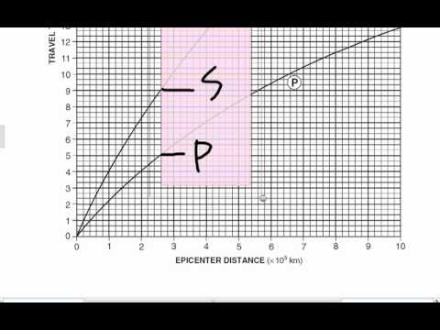
PART II: Locating an Epicenter
In order to locate an epicenter using the triangulation method you must do the following step by step:
- Record the P wave and S-wave arrival times of the seismic stations given.
- Find the S - P wave time interval (remember you are subtracting time!).
- With your S-P wave time interval, align a scrap piece of paper on the travel time (y-axis) of page 11 in your ESRT. Mark on this piece of paper the S-P wave travel time that you found →
- Now, carefully slide up your marked piece of paper until the exact distance between the P and S wave curves meet both edges of where you marked your paper. Locate the distance to the epicenter at that location on the X axis. REMEMBER, each box means 200 (km) more! And 1 is not 1 (km) its 1,000!!! (10^3)
- Using all 3 found distances to the epicenter you can now use your drawing compass for triangulation. Remember, the RADIUS of your circle is EQUAL to the DISTANCE to the EPICENTER!
- First align the compass with the map scale so that the center of the compass is at a distance of 0 km (the center ring in pic below). Put your pencil in the closest opening to meet the distance on your map scale. A more accurate way to do this is to first mark the distance to the epicenter with a scrap piece of paper on your map using the map scale (see ppt used in class for more visuals).
- Physically put the center of the compass over the city of that seismic station. Place your pencil carefully in the compass hole that most closely meets your distance marked. Draw your circle!
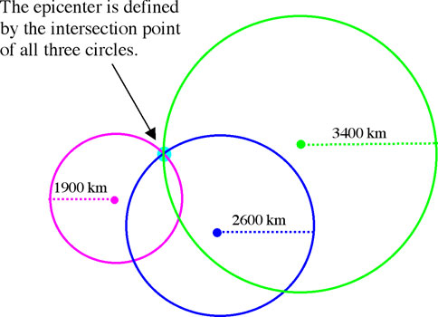
- Repeat this step 2 other times. Your circles should intersect at one point- if it makes a triangle, mark the center of the triangle as your epicenter with an “x”.
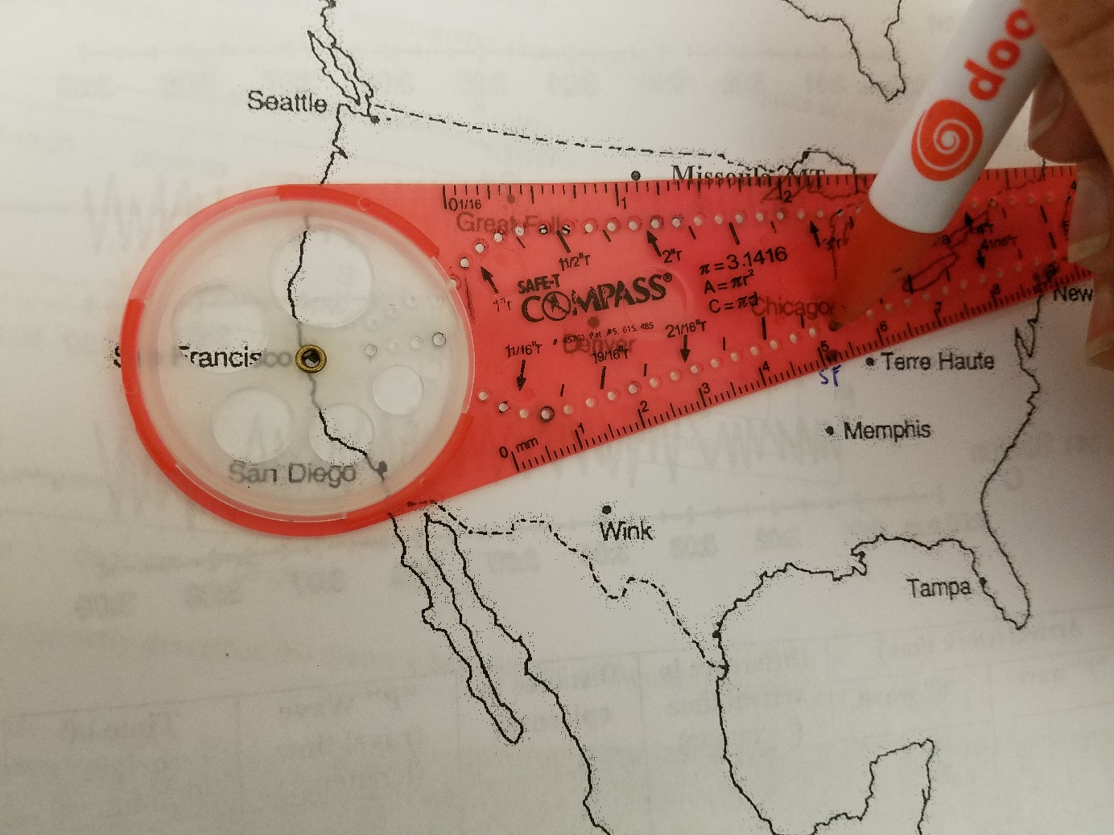
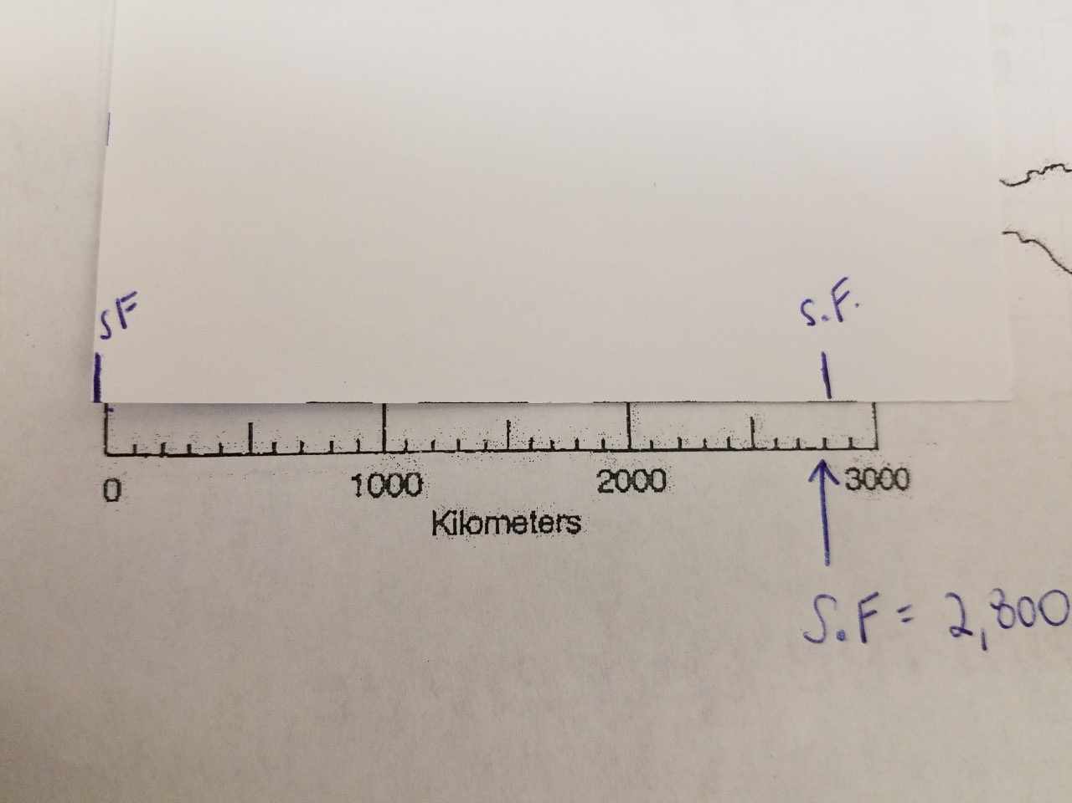
Part III: Calculating Eccentricity
All planets and objects in our solar system have eccentric orbits. This means that they are NOT a perfect circle. We give a range of eccentricity between the values of 0-1, with 0= a PERFECT circle, and 1= a straight line. Most of our planets in the solar system LOOK like they have perfect orbits, but when we measure the length of their major axis of revolution, and the distance between the sun and one other focal point, we find that this is not true.

*The closer an orbit is to 0 the LESS eccentric it is e = D (distance between foci)
* The closer an orbit is to 1, the MORE eccentric it is L (Length of major axis)

(That’s because eccentricity is a measurement of literally, how stretched out an ellipse is)

You must be able to do the following:
- Measure the distance between two focal points given to you to the nearest 10th of a cm
- Create an ellipse with a string and two pushpins using the two focal points
- Measure the Length of the major axis of that ellipse to the nearest 10th of a cm (Major axis goes straight through focal points and is length wise/longest way across)
- Calculate eccentricity and round to the nearest 1000th (equation on pg. 1 ESRT) =there are NO UNITS
- Compare your calculated eccentricity to a known eccentricity of another planet; is it greater or less eccentric? -How do you know? (Compare the numerical value to give justification. *If it’s closer to “1” it is more eccentric/more ovular if it is closer to “0” it is less eccentric/more circular*

- Mark the location on the orbit you drew which would produce the fastest orbital velocity (Remember Kepler’s laws from astronomy?)
  - The closer a planet is to the star its orbiting (always one of the two focal points), the faster it is orbiting. In the bottom right diagram, the planet is moving the fastest between points A and B.
  - The further away a planet is to the star it is orbiting, the slower it goes. The planet is moving the slowest at point C, because it is the furthest from the sun.

